NEPAL COLLEGE OF INFORMATION AND TECHNOLOGY  AFFLIIATED TO POKHARA UNIVERSITY  EXAMINATION CONTROL DIVISION  Assessment 2062 POUSH | Exam | Regular
 | Level | Bachelor | Full Marks | 100
 | Programme | BEX | Pass Marks
 | Year/Part | III/I | Time | 3 hrs

Subject: CMM 477.3 Digital Communication

- Candidates are required to give their answers in their own words as far as practicable.
- Attempt all the questions.
- The figures in the margin indicate FULL MARKS.
- Assume suitable data if necessary.

- (a) State Nyquist sampling theorems for band limited signal. How aliasing effects can be minimized? Explain. [5]
(b) Show that the Signal to Quantization Noise Ratio (SQNR) in uniform quantization equals to 3N², where N is the number of levels. [7]

OR
Show that for each extra bit used for representing each quantization level (coding) in uniform quantization, the Signal to Quantization Noise Ratio increases by 6 dB.

(c) Discuss the Interference in Digital communication System in brief. [3]

- (a) What do you mean by Delta Modulation? How delta modulation can be implemented. Explain its operation and its noises in brief. [7]
(b) A signal g (t) band limited to 3KHz is sample at the rate 40% higher than the Nyquist sampling rate. The maximum acceptable quantization error in a sample is 0.6% of the peak amplitude g_{p}(t). The quantized samples are binary coded. Find the bandwidth of the channel required to transmit the encoded binary signal. If 24 such channels are Time Division Multiplexed, determine the minimum transmission Band Width required to transmit the multiplexed signal. [8]

- (a) What do you mean by companding? Why non-uniform quantization is better than uniform quantization? Justify. [5]
(b) Describe T1 system and its hierarchy in Digital Telephony. [6]
(c) Show that the quantization error power in uniform quantization is given by
q = Δ²/12, where Δ is the step size. [4]

- (a) Represent the binary data 101011101 by the following base band representation formats: [6]
  - AMI format
  - Manchester Format
(b) Explain the Eye Pattern in brief. What can be predicted form it? [6]
(c) What do you mean by Correlative coding technique? Explain. [3]

- (a) The binary sequence 10111000101 is the input of pre-coder whose output is used to modulate a duo-binary transmitting filter, show the pre-coded sequence, the transmitted amplitude levels, the received amplitude levels and the decoded sequence. [7]
(b) State and prove Nyquist Condition for Zero ISI. [8]

- (a) For the (7,4) Linear Block code (Hamming code). Find the code word for message bit stream {0110}. If a code is transmitted and the error occurs at 6th bit position, find the corresponding syndrome value. [8]

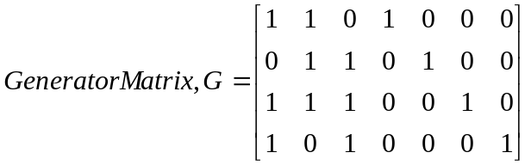

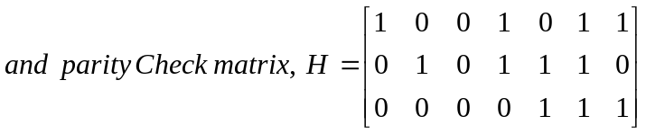

OR
Explain the Linear Block coding technique for error correction and detection in brief

(b) If g(x)=1+x+x² is a generator polynomial of (7,4) cyclic code. Find The code vector for message bit stream m={1011}. [7]

- Write Short Notes on: (any two) [2×5]
    - Convolution codes
    - Modified Duo-binary Coding
    - Analog to Digital Conversion
    - Digital Modulation

The End.

